Vehicle of Interest – Desktop

User Interface Design

1.0

January 23, 2022

Stanley De Jesus

**Table of Contents**

1. Introduction 1

1.1 Purpose 1

1.2 Scope 1

1.3 References 1

1.4 Terms, Abbreviations and acronyms 2

2. Graphical Interface Design 2

2.1 VOI Main Window 2

2.1.1 VOI – Desktop Edition / Main Window 2

2.2 VOI Inquiry 3

2.2.1 View Vehicle of Interest 1 3

2.2.2 View Vehicle of Interest 2 4

2.2.3 View Vehicle of Interest 3 5

2.2.4 Add VOI 6

2.2.5 Edit VOI 8

2.2.6 Delete VOI 9

2.3 View/Modify Record 10

2.3.1 – Select Record Type 10

2.4 Reason for Interest Records 10

2.4.1 View Reasons for Interest Records Initial 10

2.4.2 Selected Reason for Interest Records 12

2.4.3 Add Reason for Interest 13

2.4.4 Edit Reason for Interest 13

2.4.5 Delete Reason for Interest 14

2.5 View/Modify Vehicle Make 15

2.5.1 Vehicle Make Initial 15

2.5.2 Vehicle Make Selected 15

2.5.3 Add Vehicle Make 16

2.5.4 Delete Vehicle Make 17

2.6 View/Modify Vehicle Model 17

2.6.1 Vehicle Model Initial View 17

2.6.2 Select Vehicle Model 18

2.6.3 Add Vehicle Model 19

2.6.4 Delete Vehicle Model 20

# 1. Introduction

## 1.1 Purpose

This document outlines the Vehicle of Interest desktop application Graphical User Interface (GUI) design. It will showcase how the user interface will look for the user and the general functionality of all of its components. These components interact with other components or communicate using the provided controller through the database. The reader can pick up this document and create the design with coding experience in Java Swing GUI development.

## 1.2 Scope

The Vehicle of Interest project consists of three different applications. These are Desktop, Web, and Mobile. The document scope will be focused on just the Desktop application. The GUI will be created using the java swings, and it will be developed using the NetBeans IDE. The window designs were created using the pencil application. Each screen functionality is explained as internal, external, or both. Internal functionality refers to application interfacing with the database. External functionality describes the opposite and focuses on fundamental GUI component interactions. Last, each screen description is standalone, so only the developing GUI screen section needs to be analyzed.

## 1.3 References

1. *Vehicles of Interest Introduction*. (n.d.). Retrieved from https://learn.umgc.edu/d2l/le/content/627414/viewContent/24788069/View

*2. VOI Desktop Interface Design Instructions*. (n.d.). Retrieved from https://learn.umgc.edu/d2l/le/content/627414/viewContent/24788077/View

## 1.4 Terms, Abbreviations and acronyms

GUI – Graphical User Interface

IDE – Integrated Development Environment

UI – User Interface

VOI – Vehicle of Interest

# 2. Graphical Interface Design

## 2.1 VOI Main Window

### 2.1.1 VOI – Desktop Edition / Main Window

**Screen Name:** Main Window

**Image**:

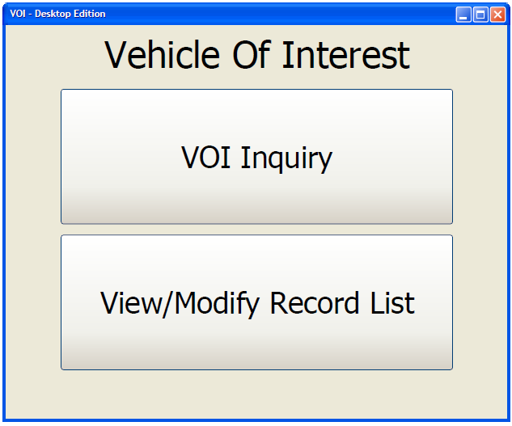

Figure 1

**External UI functionality**:

* When the user clicks on the VOI Inquiry, a new screen will open, showing the View Vehicle of interest screen (see section 2.2.1).
* When the user clicks on the View/Modify Record List, a new window will open, showing the View/Modify window (see section 2.3.1).

## 2.2 VOI Inquiry

### 2.2.1 View Vehicle of Interest 1

**Screen Name: View Vehicle of Interest 1**

**Image**:

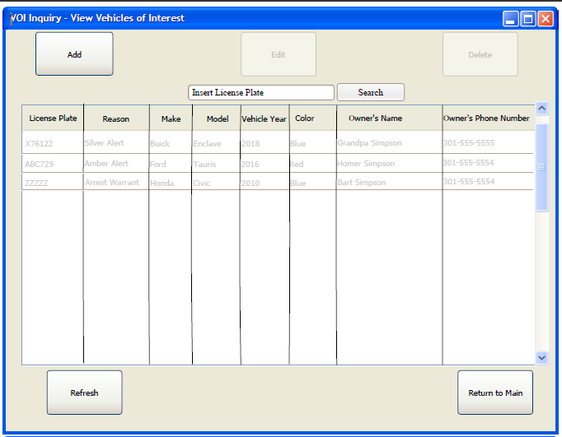

Figure 2

**Internal UI functionality**:

On this screen, the application connects to the database and automatically displays a list of all the VOI records in the table. The Edit and Delete buttons will be disabled as it does not meet requirements (see section 2.2.2). When the Refresh button is clicked, the application will connect to the database and request a query for all Vehicles of Interest records. Afterward, it will remove the table data and repopulate with the new query. The Return to Main will close the VOI Inquiry page.

**External UI functionality**:

Once the user clicks on the VOI inquiry button, the VOI inquiry screen is opened on top. When the user clicks on the Add button, the add screen will appear (see 2.2.4). With an enabled button, hovering over your mouse will provide the user the shortcut/accelerator if it exists. The button functionality and their shortcut/accelerator and description are listed.

|  |  |  |
| --- | --- | --- |
| **Button** | **Shortcut/accelerator** | **Description** |
| Refresh | Alt+R | Refreshes the table with updated query |
| Add | Alt+A | Opens the VOI add screen |
| Return to Menu/Close Button | Alt+C | Close the current window and makes the main window active. |

Table 1

### 2.2.2 View Vehicle of Interest 2

**Screen Name:** View VOI – Select Record

**Image**:

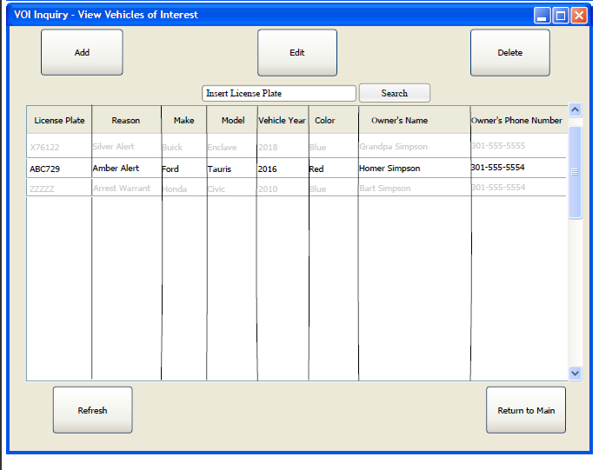

Figure 3

**External UI functionality**: In addition to the first screen functionality, it has the following functionality. When the user clicks on a record, it highlights the row and enables the edit and delete buttons. See table 2 for details on these buttons

|  |  |  |
| --- | --- | --- |
| **Button** | **Shortcut/accelerator** | **Description** |
| Edit | Alt+E | It opens up the VOI edit window (section 2.2.5) |
| Delete | Alt+D | Opens up the VOI delete window (section 2.2.6). |

Table 2

### 2.2.3 View Vehicle of Interest 3

**Screen Name: View VOI - Search**

**Image**:

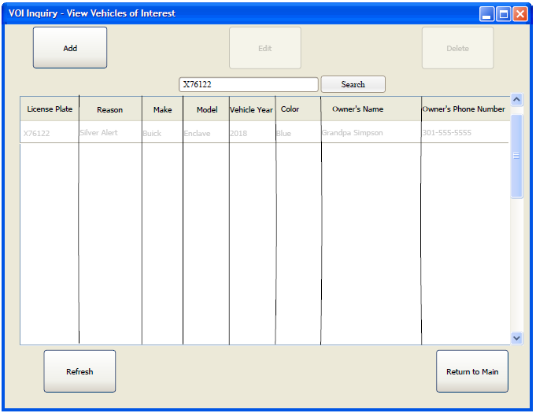

Figure 4

**Internal UI functionality**: When the user clicks on the search with a valid license plate, it queries the database and updates the table. If the Refresh button is clicked, it will repopulate the table with all existing VOIs. Otherwise, it will show nothing.

### 2.2.4 Add VOI

**Screen Name: VOI - Add**

**Image**:

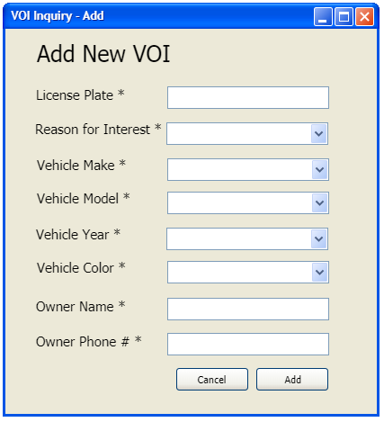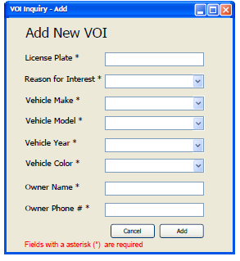

Figure 5 Figure 6

**Internal UI functionality**: When the user clicks the add button, it first performs input validations to confirm there are values in each field. If one or more required fields (identified with the asterisk at the end) are empty, the screen will add an error message at the bottom of the window (figure 6). If all required fields have a value, it will connect to the database and add a record into the Vehicle of Interest table. The dropdown lists will populate the option based on their respective table. See table 3. The vehicle year will be populated using a data object and for loop. The color will be extracted from internal files. The tables and internal files will have the options for their drop-down box.

|  |  |
| --- | --- |
| **Drop Down** | **Table Name** |
| Vehicle Make | VEHICLE_MAKE |
| Vehicle Model | VEHICLE_MODEL |
| Reason for Interest | REASON_FOR_INTEREST |

Table 3

**External UI functionality**: If the user clicks the cancel button, it will close the VOI Inquiry - add screen. The add button will close if it passes data validation and after completing database operations.

### 2.2.5 Edit VOI

**Screen Name: VOI - Edit**

**Image**:

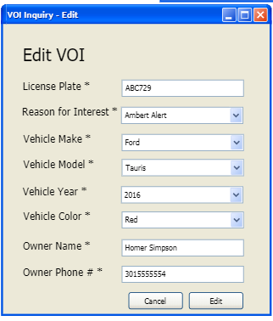

Figure 7

**Internal UI functionality**: When the user clicks on the edit screen, it will query the database for the License Plate number, which is the primary key for the VEHICLE_OF_INTEREST table. It will then add that information to the window. When the user clicks on the edit button, it updates the VOI table with the information listed on this screen.

**External UI functionality**: The default values for these fields will be from the database query. If changes are made to the drop-down menu, it will query the database for a reason for interest, vehicle make, and vehicle model tables and return the values as down-down menu options. See table 3. The cancel button closes the edit window, and the edit button will update the database and close it once the database action is complete.

### 2.2.6 Delete VOI

**Screen Name: VOI - Delete**

**Image**:

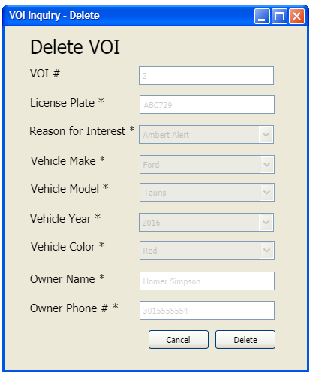

Figure 8

**Internal UI functionality**: When the user clicks the delete, it will delete the entry from the VEHICLE_OF_INTEREST database table.

**External UI functionality**: The cancel button will close this window. All text fields and drop-down boxes will be disabled. It prevents modification before performing the delete function. The delete button will also close the window once it is clicked and its internal functionality is complete.

## 2.3 View/Modify Record

### 2.3.1 – Select Record Type

**Screen Name: VOI – View/Modify Record**

**Image**:

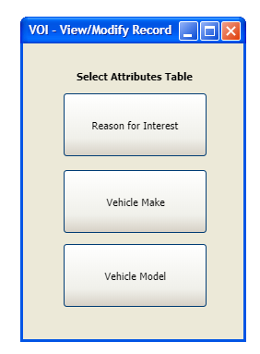

Figure 9

**External UI functionality**: The application will open a new window with the table records when the user clicks any of these buttons. The list identifies what screen each button will open

* Reason for Interest –> Section 2.4
* Vehicle Make -> Section 2.5
* Vehicle Model -> Section 2.6

## 2.4 Reason for Interest Records

### 2.4.1 View Reasons for Interest Records Initial

**Screen Name:** VOI – View Reasons for Interest Initial

**Image**:

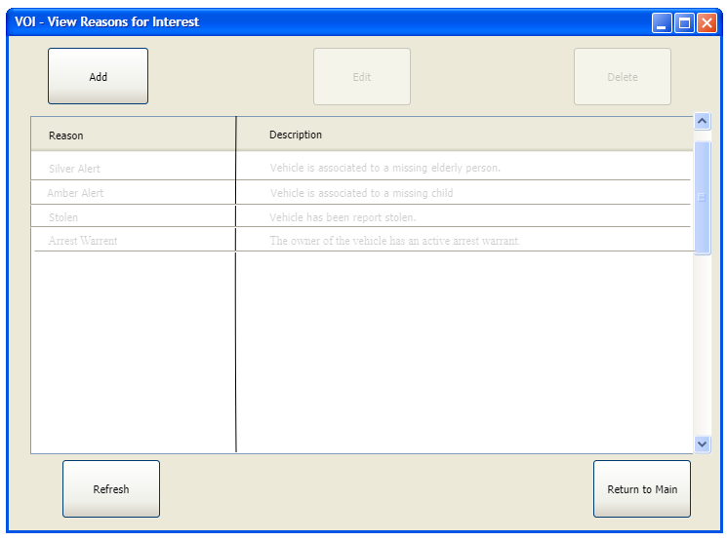

Figure 10

**Internal UI functionality**: This screen automatically populates the table with the Reason for Interest table records. The refresh will request a new table and repopulate the table.

**External UI functionality**: When the user clicks the add button, it opens the Add Reason for Interest Screen. See Section 2.4.3. The return to Main will close this window. This window has the same shortcuts/accelerators as the VOI inquiry.

* Add button -> Alt+A
* Refresh button -> Alt+R
* Return to Main/Close button -> Alt+C

### 2.4.2 Selected Reason for Interest Records

**Screen Name: VOI – View Reasons for Interest Selected**

**Image**:

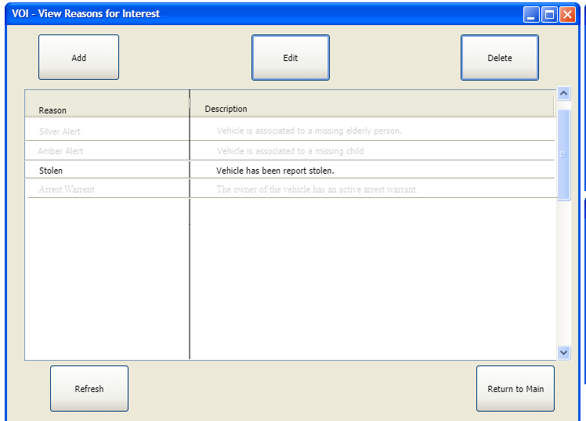

Figure 11

**External UI functionality**: The application will highlight the entire record on the table when a record is selected. It will also enable the Edit and Delete buttons. These buttons open up a new window and contain the following shortcuts/accelerators

* Edit (Alt+E)-> Edit Reason for Interest. See section 2.4.4;
* Delete (Alt+D) -> Delete Reason for Interest. See section 2.4.5.

### 2.4.3 Add Reason for Interest

**Screen Name: VOI - Reason for Interest - Add**

**Image**:

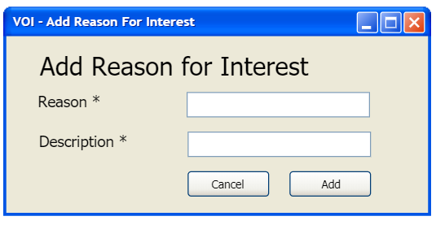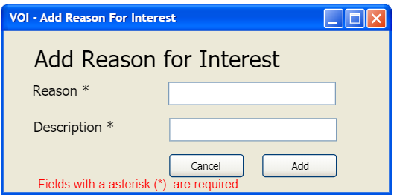

Figure 12 Figure 13

**Internal UI functionality**: When the add button is clicked, data validation checks whether required fields (identified with an asterisk) are empty. If a field is empty, it will refresh with the screen with a message in red stating, “Fields with an asterisk (*) are required. If all fields have user input, it will add a row in the Reason for Interest table.

**External UI functionality**: The cancel button will close the window and perform no operation. The add button closes once the add database operation is complete.

### 2.4.4 Edit Reason for Interest

**Screen Name: VOI – Reason for Interest - Edit**

**Image**:

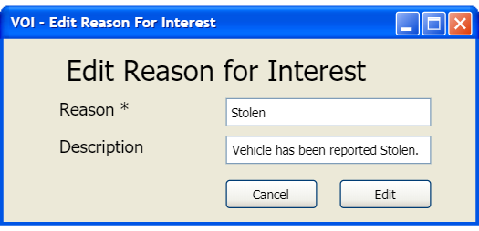

Figure 14

**Internal UI functionality**: The Edit Reason for Interest screen will query the database for a reason for interest using the Reason field. The Edit button will update the enabled text field data by replacing table records with those text fields.

**External UI functionality**: The Reason text field is disabled to prevent user errors/issues. The cancel button will close the window. The edit screen will also close once the database has finished updating the record.

### 2.4.5 Delete Reason for Interest

**Screen Name: VOI – Reason for Interest - Delete**

**Image**:

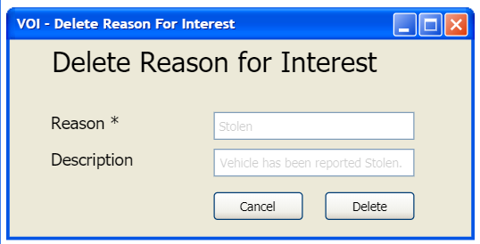

Figure 15

**Internal UI functionality**: The Delete Reason for Interest screen will delete the database record once the delete button is pressed.

**External UI functionality**: All text fields are disabled to avoid changes and potential confusion about what record is deleted. The close button closes the window. The delete button closes once it performs the delete operation for the database table record.

## 2.5 View/Modify Vehicle Make

### 2.5.1 Vehicle Make Initial

**Screen Name: Vehicle Make 1**

**Image**:

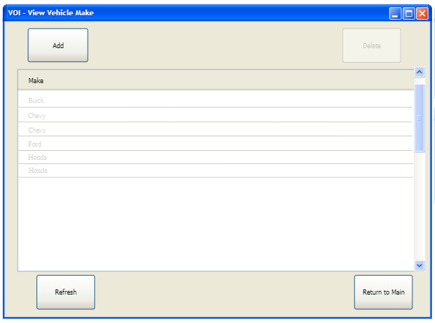

Figure 16

**Internal UI functionality**: This screen will automatically populate the Vehicle Make table records. The refresh will request a new table and repopulate the table.

**External UI functionality**: When the user clicks the add button, it opens the Add Vehicle Make Screen. See Section 2.5.3. The return to Main will close this window. This window has the same shortcuts/accelerators as the VOI inquiry.

* Add button -> Alt+A
* Refresh button -> Alt+R
* Return to Main/Close button -> Alt+C

### 2.5.2 Vehicle Make Selected

**Screen Name: Vehicle Make 2**

**Image**:

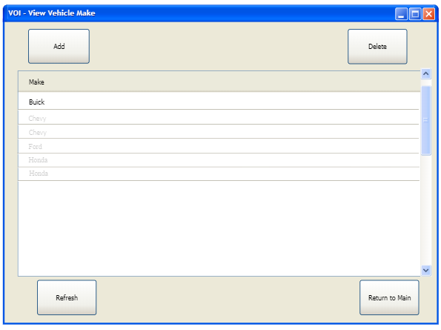

Figure 17

**External UI functionality**: The application will highlight the entire record on the table when a record is selected. It will also enable the Edit and Delete buttons. These buttons open up a new window and contain the following shortcuts/accelerators

* Delete (Alt+D) -> Delete Vehicle Make. See section 2.5.5.

### 2.5.3 Add Vehicle Make

**Screen Name: Vehicle Make - Add**

**Image**:

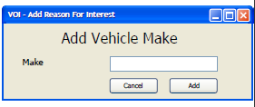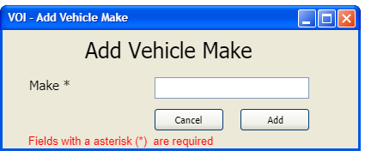

Figure 18 Figure 19

**Internal UI functionality**: When the add button is clicked, data validation checks whether required fields (identified with an asterisk) are empty. If a field is empty, it will refresh with the screen with a message in red stating, “Fields with an asterisk (*) are required. If all fields have user input, it will add a row in the Reason for Interest table.

**External UI functionality**: The cancel button will close the window and perform no operation. The add button closes once the add database operation is complete.

### 2.5.4 Delete Vehicle Make

**Screen Name: Vehicle Make - Delete**

**Image**:

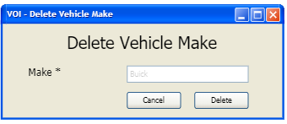

Figure 20

**Internal UI functionality**: The Delete Vehicle Make screen will delete the database record once the delete button is pressed. If the make is added as part of a model, it will attempt the make deletion but will be unsuccessful as it is a foreign key to the model table. To successfully delete the make, the user must delete all models with the same make from the model table. Then perform the make deletion.

**External UI functionality**: All text fields are disabled to avoid changes and potential confusion about what record is deleted. The close button closes the window. The delete button closes once it performs the delete operation for the record stored in the database.

## 2.6 View/Modify Vehicle Model

### 2.6.1 Vehicle Model Initial View

**Screen Name: VOI -Vehicle Model**

**Image**:

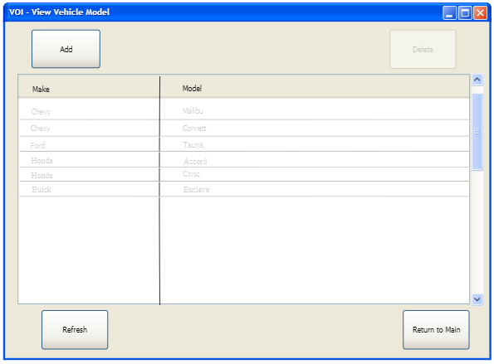

Figure 22

**Internal UI functionality**: This screen will automatically populate the table with vehicle model records. The refresh will request a new table and repopulate the table.

**External UI functionality**: When the user clicks the add button, it opens the Add Vehicle Model Screen. See Section 2.6.3. The return to Main will close this window and open the VOI main window. This window has the same shortcuts/accelerators as the VOI inquiry.

* Add button -> Alt+A
* Refresh button -> Alt+R
* Return to Main/Close button -> Alt+C

### 2.6.2 Select Vehicle Model

**Screen Name: VOI – Vehicle Model**

**Image**:

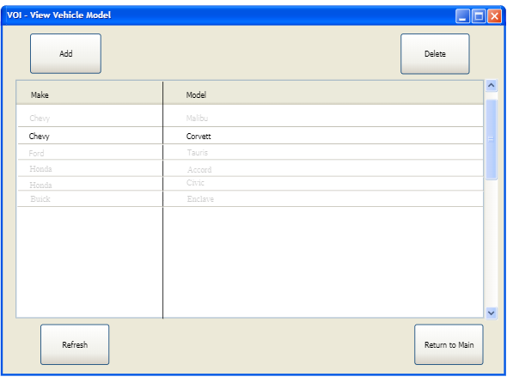

Figure 23

**External UI functionality**: The application will highlight the entire record on the table when a record is selected. It will also enable the Edit and Delete buttons. These buttons open up a new window and contain the following shortcuts/accelerators

* Delete (Alt+D) -> Delete Vehicle Model. See section 2.6.5.

### 2.6.3 Add Vehicle Model

**Screen Name: VOI - Vehicle Model - Add**

**Image**:

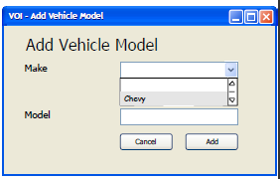 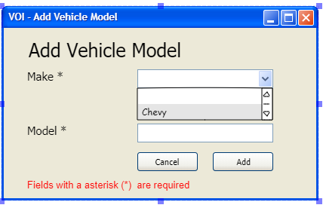

Figure 24 Figure 25

**Internal UI functionality**: When the add button is clicked, data validation checks whether the required fields (identified with an asterisk) are empty. If a field is empty, it will refresh with the screen with a message in red stating, “Fields with an asterisk (*) are required.” If all fields have user input, it will add a row in the VEHICLE_MODEL table.

**External UI functionality**: The cancel button will close the window and perform no operation. The add button closes once the add database operation is complete.

### 2.6.4 Delete Vehicle Model

**Screen Name: VOI – Vehicle Model - Delete**

**Image**:

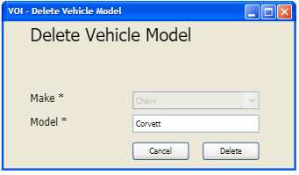

Figure 27

**Internal UI functionality**: The Delete Vehicle Model screen will delete the database record once the delete button is pressed.

**External UI functionality**: All text fields are disabled to avoid changes and potential confusion about what record is deleted. The cancel button closes the window. The delete button closes once it performs the delete operation for the record stored in the database.